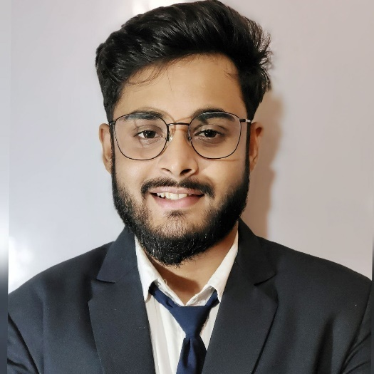

9064429198

[soumyadeepchakraborty207@gmail.com](mailto:soumyadeepchakraborty207@gmail.com)

Kolkata ,India

www.linkedin.com/in/soumyadeep-chakraborty-1a844a22b/

<https://github.com/soumyadeepchakraborty186>

**SKILLS**

* C
* PYTHON
* MACHINE LEARNING
* SQL
* HTML,CSS
* OS
* DBMS
* Data Structure & Algorithm
  + **PRODIGY INFOTECH** Oct 2023 – Nov 2023

Joined as a Machine Learning Intern

* + **CODSOFT** Sep 2023 – Oct 2023

Joined as a Web development Intern

* + **BHARAT INTERN** Sep 2023 – Oct 2023

Joined as a Machine Learning Intern

* + **CODSOFT** Sep 2023 – Oct 2023

Joined as a Machine Learning Intern

**INTERNSHIPS**

**HOBBIES**

* DRAWING
* DOING PROJECTS
* LISENING MUSIC
* TRAVELLING
* ENGLISH
* BENGALI
* HINDI

**LANGUAGES**

**SOUMYADEEP CHAKRABORTY**

**PERSONAL DETAILS**

* Father’s Name: Malay Kumar Chakraborty
* Nationality: Indian
* Date of Birth: 18/06/2003
* Permanent Address: Bhangamora,Tarakeswar,Hooghly,712410

**ACHIVEMENTS**

* + Machine Learning With Python By IBM (Coursera)
  + Generative AI :The Evolution of Thoughtful Online Search(Linkedin Learning)
  + Machine Learning with Python(Linkedin Learning)

* + Brain tumor cell segmentation from MRI using supervised Machine Learning strategies.
  + Comment Toxicity checker using Deep Learning like keras,TensorFlow etc.
  + Raspberry Pi Car Number Plate and Location History Tracking Using Machine Learning ,SQL etc.

**PROJECTS**

**EDUCATION**

* + **BACHELOR OF TECHNOLOGY (CSE WITH AI & ML)**
    - University of Engineering & Management ,Kolkata.
    - 2021-Present
  + **HIGHER SECONDARY (WBCHSE)**
    - Bhangamora NKNCM Institution , Tarakeswar.
    - 2021
    - Percentage – 89.6
  + **SECONDARY(WBBSE)**
    - Bhangamora NKNCM Institution,Tarakeswar.
    - 2019
    - Percentage-87

I am looking for a challenging job where I can utilize my knowledge .I want to learn from the organization and growth with the organization.

**CAREER OBJECTIVE**